Communication and Language Development  Try singing the Happy Song we sing at school.  This is my happy song, I like to sing it all day long. I’ll teach you the words, and you can sing along! Happy, happy happy!  Can you sing it fast and slow? What about with a high voice or a low voice? | Physical Development / PE  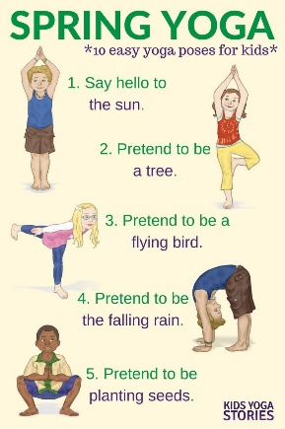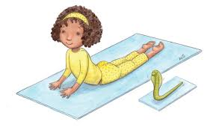  Take your socks and shoes off and try these yoga poses. | Personal, Social and Emotional Development / PSHE  Practice taking turns in a game you enjoy. You might try taking turns to add a brick to a tower, or taking turns to roll the dice and move around the board in snakes and ladders. |  | Literacy Development / English  Can you remember Mr Gumpy’s Outing? Singing Hands have just made a Makaton version. Join in with the Makaton and see how much of the story you can remember. Which animals went for a ride? What happened at the end?  Search online for ‘Singing Hands Mr Gumpy’s Outing’.
Because school is closed for now, here are some suggested activities that you could do at home.

Remember to ‘Be Safe, Be Kind and Always Try Your Best’

The title of your child’s topic is: Green Fingers
Mathematics  Watch and join in with Class 1’s maths songs.  Search online for:  Super Simple Songs 10 Little Fishies  Super Simple Songs 5 Little Ducks  Count along on your fingers.  Super Simple Songs Shape Song 1  Can you find the shapes at home? | Understanding the World / History / Geography / RE  Try watching some seeds grow on your windowsill. Soak lentils or dried beans or peas for 24hours then leave in a sieve and rinse daily. Watch them germinate and grow little roots and leaves. How long does it take? Can you make a photo diary? What do they taste like?  You could also use seeds from a pepper or try placing carrot or beetroot tops in water. |  | Expressive Arts and Design  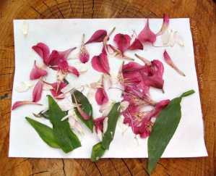  Try making a collage from leaves and flowers you might find on your daily walk, or in your garden or at home. |  | Reading  Share a favourite book with an adult. Can you find any stories about plants and gardens?  You could try Grow Your Own by Esther Hall or Jasper’s Beanstalk by Nick Butterworth and Mick Inkpen (there are lots of versions of this one online).  Which is your favourite?

