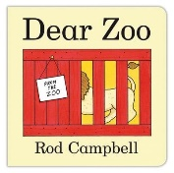
Speech and Language Therapy – Online Resources –

Dear Zoo

We have created a short online resource for the book Dear Zoo, you can use this is the following ways to support your child’s speech, language and communication:

- To watch together and learn/copy the Makaton signs.

- To watch alongside looking at the book yourself if you have this at home and copying the words and signs.

- To encourage your child to copy the spoken words for the animals they see.

- To encourage your child to copy the word or sign ‘back’ when I pause each time.

- To watch and then retell, so your child then tries to remember which animals they saw. You can use signs, spoken words and if you would like PECS pictures or symbols please let us know as we can send these home for you.

- To watch and listen to the story and then watch and support your child to answer the questions. One video is to support your child to answer ‘who’ questions and one is aimed to support your child to use the sign/word for the descriptive words in the story and to answer a ‘why’ question.

- You can also use these videos to then think up your own questions or activities around the story which will support your child’s sign, spoken words, PECs or other forms of communication.

If you would like any further resources please do get in touch either by ringing school or on the following details:
Hayley Fawcett
Speech and Language Therapy
01670 293163
Hayley.fawcett@nhs.net

