“What I learn today, prepares me for tomorrow”

Residential Provision

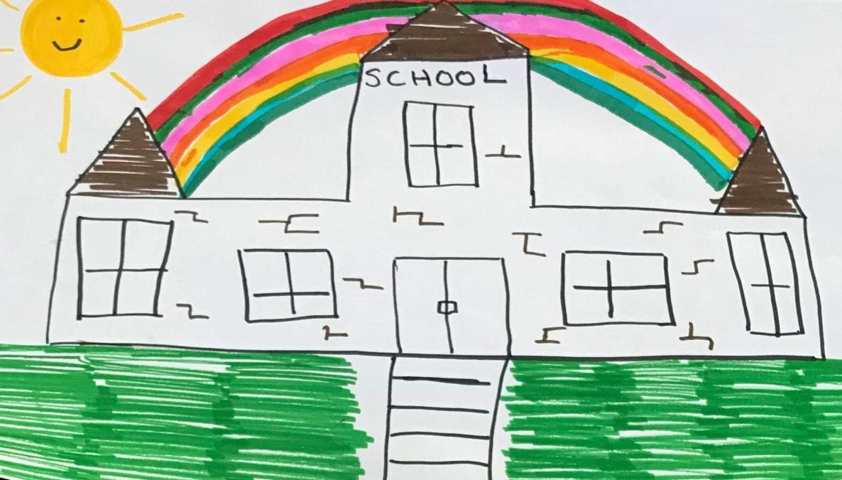
Statement of Purpose
2021 – 2022

Policy Location: | Last Revised: | Review Due: | Person Responsible:
Google drive / shared file | September 2021 | September 2022 | Katrina Green, Head of Care
Location of Barndale House School
Berwick and the North
Travelling south along the A1 take the slip road signposted for Alnwick (B1340). Branch left, then at T-junction turn right onto the (B1340) (signposted B1340 Alnwick, Berwick) and cross road bridge. Continue forward onto the B1340 entering Alnwick. Turn right onto the B6346. Bear left onto Market Street B6341. Turn right onto Lagny Street B6346. Turn left onto Howling Lane. Arrive at Barndale House School.

From Newcastle and the South
Travelling north along A1 merge onto the A1068 (signposted A1068 Alnwick, Alnmouth) Entering Alnwick. At Oaks Hotel Roundabout take the second exit onto the B6346 (signposted Town Centre). Bear left onto Market Street B6341. Turn right onto Lagny Street B6346. Turn left onto Howling Lane. Arrive at Barndale House School.

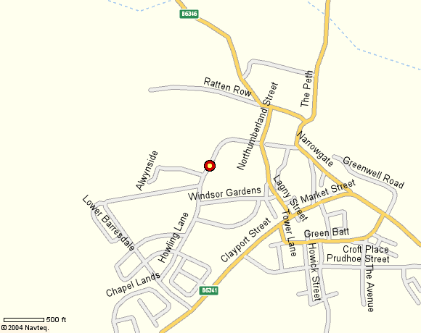

Howling Lane, Alnwick NE66 1DQ
01665 602541
admin@barndalehouse.northumberland.sch.uk
barndalehouse.northumberland.sch.uk
@barndaleschool

Headteacher: Mr. Mark Phillips
Head of Care: Miss Katrina Green

Introduction to Barndale House School
Our Pledge
What I learn today, prepares me for tomorrow
Our personalised and flexible approach to teaching and learning will ensure that your child is placed at the heart of everything we do. Our team of brilliant staff are highly skilled, caring, hardworking and committed to promoting every aspect of your child’s intellectual, social, emotional and physical development. We understand and appreciate that progress for every child will look very different and we recognise this in numerous ways. We promote a positive and supportive culture in school where every achievement is recognised and celebrated.
We know how valuable each day at school is. We therefore work hard to ensure that all of our pupils are happy, safe and have access to a meaningful, FUN and balanced curriculum.
We see parents and carers as key partners in the education of their young people and aim to work very closely with families. We have a calendar of events, which you are encouraged to attend and we will communicate with you through our home-school diary system, but you are also very welcome to come into school at any time to discuss any issues, concerns or ideas that you may have. You know your child best so we believe that working in partnership is the best way forward. Our vision is for Barndale House School to become a centre of excellence within the field of special education, training and support and together we will make sure that we continue on our journey towards this goal. We may be a small school (at the moment!) but we have some big ambitions.

Mission Statement
‘A small school with big ambitions’
At Barndale House School, we are committed to providing a high quality education in a safe, welcoming and supportive environment where different abilities and individuality are accepted, respected and celebrated. We believe that every child and young person has something special to offer the world and that our school is a place where this can be nurtured and realized.

Our Aims:
All of our learners will…
- have access to a meaningful, creative and balanced curriculum which enables them to progress socially, emotionally, intellectually and physically
- receive high quality teaching, learning and care within a happy, fun and stimulating environment
- develop the skills to interact and communicate with others and to enjoy positive, meaningful relationships with a range of people
- become confident, active participants within their local community and beyond
- be prepared for an adult life in which they have the greatest possible degree of independence

Our Values
Our values underpin everything we do at Barndale; they have been agreed in consultation with staff, pupils, parents and other members of our school community. Our values are embedded within all aspects of school life and are promoted through assemblies, lessons, social times and other extracurricular activities.
As a school, we value:
- Kindness – looking after each other
- Equality – feeling special
- Respect – looking after our school
- Co-operation – working together
- Determination – aiming high and trying your best

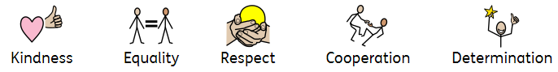
Registered Provider and Senior Leadership Team
The Registered Provider: Mrs Cath McEvoy - Carr
Executive Director of Young people's Services,
Northumberland County Council
County Hall
Morpeth
Northumberland
NE61 2EF

Tel: 07785285677

Responsible Individual: Mr Mark Phillips
Head Teacher
Barndale House Residential Special School
Howling Lane
Alnwick
Northumberland
NE66 1DQ

Head of Care: Miss Katrina Green
Head of Care
Barndale House Residential Special School
Howling Lane
Alnwick
Northumberland
NE66 1DQ

Residential Team
Our team consists of:
- Head of Care
- Residential Shift Coordinators
- Residential Key Workers
- Waking Night Attendants

Residential Key Worker
Your child will be allocated a keyworker who will ensure your child feels safe and secure during their stay. Our team will strive to enhance the development of your child’s independence and social skills through leisure pursuits and community activities. We will monitor and assess your child’s personal progress through individual learning plan targets. We work towards meeting a whole range of social, spiritual, emotional and intellectual needs in a way that promotes dignity, choice and independence.

Staff Start | 2.30pm | Staff Finish | 9.15am
Learners Start | 3pm | Learners Leave | 9am
Staff Briefing | Daily 2.30pm | Staff Meeting | Thursday 2.30pm
Head of Care | Rotation: 9am – 5pm  12pm – 9pm | Overnight staff | 1 waking night attendant  + sleep in

The 24-hour curriculum
(Step In, Step Up, Step Forward)
At Resi we provide an extended curriculum, which goes beyond the school day. We refer to this as the 24-hour curriculum. Every second of your child’s day is seen as a learning opportunity with areas such as personal, social, behavioural and self-help skills being taught alongside the academic curriculum. We are committed to preparing your child for adult life from the moment they:

'Step In'
to our school

'Step Up'
and discover their own talents and interests

'Step Forward'
Into adulthood
Our three residential ‘STEP’ programs focus on the 4 key themes within the Preparing for Adulthood agenda: Independent Living, Employment, Community Inclusion and Health. Here is how we link our provision to the Preparing for Adulthood themes and also what a pupil can expect from each of our residential ‘STEP’ programmes:

 | Independent Living | Employment | Community Inclusion | Health
STEP IN  (7-13 years) | Washing and dressing  Personal hygiene  Shopping  Public transport  Road safety | Adapting to new people and environments  Real world visits  Meeting role models from the world of work | Making friends  Social interaction  Group activities | Healthy eating  Exercise
STEP UP  (7-13 years) | Budgeting  Cooking  Independent living skills  Travel training | Real world visits linked to interests  Tailored / themed workshops delivered by employers | Youth club  Online safety  Local area visits  Planning journeys | Healthy choices  Looking after self  Basic First Aid  Puberty  RSE workshops  mental wellbeing
STEP FORWARD  (14-19 years) | Life Skills  Understanding bills  Managing own time  Home safety | Volunteering projects  Micro businesses / enterprise projects (e.g. community café’ project) | Community safety  Knowing where to go for help and advice (e.g. emergency services)  Community action projects | Role of the GP  Understanding relationships (choices)  Learning about health appointments

Gateway Award
The Gateway Award is an accredited course that consist of three levels (Bronze, Silver and Gold), made up of five different sections. These include Hobbies, Fitness, Volunteering, Lifestyle, and the Gateway Challenge.
The award uses activities in areas of everyday life to help participants experience new things, develop life skills, build confidence, become more independent, improve health and wellbeing, make new friends and most importantly have fun

Gold Minimum of 18 months
 | Requirements | Timescales
Hobbies | Young people/young people plan and carryout a project on a hobby from one of the following three sections: arts and crafts, collections or recreation | Minimum of 6 months averaging at least 1 hour per week  Minimum of 12 months averaging 1 hour per week
Fitness | Young people/young people choose up to five new fitness activities to participate in. for example: dance classes, swimming, badminton, football etc.
Lifestyle | Young people/young people choose two new lifestyle topics to learn about different from the bronze and silver levels. for example first aid, healthy eating, budgeting etc.
Volunteering | Young people/young people research and choose a volunteering activity that will benefit their local community. (note: this must be done with a Volunteering organisation)
Gateway Challenge | Young people/young people identify a challenge, activity or project to explore - this can be personal, group or adventure challenge and must be done by linking with another group or organisation. | 4 days planning and 3 days on the activity or project
Silver Minimum of 12 months
 | Requirements | Timescales
Hobbies | Young people/young people choose a hobby from one of the following three sections: arts and crafts, collections or recreation | Minimum of 3 months averaging at least 1 hour per week for each of these three sections
Fitness | Young people/young people choose three new fitness activities to participate in. for example: dance classes, swimming, badminton, football etc.
Lifestyle | Young people/young people choose three lifestyle topics to build on what they learnt from the bronze level, including well-being, confidence, safety and communication
Volunteering | Young people/young people choose to participate in a volunteering activity that will benefit their local community. Volunteering for an organisation where possible. For example: running a recycling project, volunteering at a local charity, local litter pick etc. | Minimum of 6 months averaging 1 hour per week
Gateway Challenge | Young people/young people choose a challenge, activity or project that they would like to participate in. this can be personal to the group, e.g. a personal challenge or trip to a local amenity. | 3 days planning and 2 days on the activity or project
Bronze Minimum of 6 months
Section | Requirements | Timescales
Hobbies | Young people/young people choose a hobby from one of the following three sections: arts and crafts, collections or recreation | Minimum of 3 months averaging at least 1 hour per week for each of these four sections
Fitness | Young people/young people choose two new fitness activities to participate in. for example: dance classes, swimming, badminton, football etc.
Lifestyle | Young people/young people choose two new lifestyle topics to learn about for example first aid, money, independence, health and healthy eating
Volunteering | Young people/young people choose to participate in a volunteering activity that will benefit their local community. For example: running a recycling project, volunteering at a local charity, local litter pick etc.
Gateway Challenge | Young people/young people choose a challenge, activity or project that they would like to participate in. this can be personal to the group, e.g. a personal challenge or trip to a local amenity. | 2 days planning and day on the activity or project

The structure of a Residential Evening

 | 3.30-4.00pm | 4.00 – 5.00pm | 5.00-6.00pm | 6.00-7.00pm | 7.00pm -8.30pm | 8.30 - 9.30pm
Monday | Unpack cases Make beds  Choose tea | Activity 1 | Tea  Personal Hygiene Relaxation | Activity 2 | Bath/shower / Diaries | Supper / Relaxation / Bedtime
Tuesday |  | Activity 1 |  | Activity 2 | Bath/shower / Diaries | Supper / Relaxation / Bedtime
Wednesday |  | Activity 1 |  | Activity 2 | Bath/Shower / Diaries / Supper | Relation / story time / bedtime
Thursday |  | Activity 1 |  | Activity 2 | Bath/Shower / Diaries / Supper | Relation / story time / bedtime
Monitoring Individual Progress
Education and progress monitoring
The progress of our young people is incredibly important and as such, we will communicate this throughout the year.
We will update you with:
- Academic progress– how learning has improved
- Holistic progress– how social, emotional, cognitive skills have improved
- EHCP progress- how the long and short terms aims are progressing
We will communicate this using the following tools:
- Home/residential diary.
- My achievements this half term – including photos.
- Evisense
- Parent evenings
- Open door policy and appointments.

Individual Care plans
An individual care plan will be developed in partnership with parents/carer’s, your child and any other professional who can advise on your child’s individual needs. This process ensures that all staff know how to support your child effectively and provides clarity of what needs to be done, when and by whom.
The plan includes:
- Health needs and Health promotion
- Care needs including safeguarding and promoting welfare
- Physical and emotional needs
- Educational needs and attainment targets
- Cultural, religious, language and racial needs and how they will be met.
- Leisure and recreational needs
- Contact arrangements with parents/carers and family.

EHCP Meetings
These are held annually, in school, to review the progress of the Education, Health & Care Plan (EHCP). These meetings review the current EHCP, health/therapy reports (if applicable), school reports, residential reports, social care reports (if applicable) and ultimately the parent and pupil views. The new plan is agreed and targets set/reviewed as part of the process. Barndale organises these meetings and you will get an invite and reports at least two weeks prior.

Young people’s rights
We believe that all young people whatever their background, ethnicity or gender have the right to be treated fairly, equally and with respect. We encourage all young people to value themselves and others and to respect property.
All young people accessing the residential provision have the right to be free from abuse, fear and oppression and to experience safety and security. They have the right to be heard and they will be listened to.

Liaising with Parents/Carers
Communication between home and school is incredibly important to support the progress of your child, awareness of any obstacles and to agree strategies. Building the rapport and professional relationship can make discussions that are more difficult much easier. In most cases, this can be recorded in the Resi-home diary that all young people have. In cases which are more sensitive than a phone call would be more appropriate. On rare occasions parents may request emails- this should be avoided unless essential.
We have a number of ways we communicate:
- Written– Using our communication book
- Telephone– 01665 602541
- E-mail– admin@barndalehouse.northumberland.sch.uk
- Class e-mail– Class1/2/3/4/5/6@barndalehouse.northumberland .sch.uk
- Face to face– before or after school, parents evenings, EHCP meetings
- Evisense– our learning evidence platform (New Sept 2021)

Whilst we always try to be available for our parents and carers, it is important to note that this will only be during residential working hours and dependent on staff availability.
The Environment, Facilities and Services
Barndale House School is on a split complex and we have two buildings within the same grounds. The main building is situated on Howling Lane and this is where you will find the residential provision. We have a kitchen, dining room, lounge, studio, hygiene room, sensory room, bedrooms, relaxing areas, a games room and bathroom facilities.
Outdoors there is an Eco garden, playground, field, play areas and gardening areas including a greenhouse.

A wide range of activities and leisure pursuits are provided both indoors and outside

Bedroom Accommodation and Sleeping Arrangements
Your child will be allocated its own personal space/bedroom pod. They will have access to a lockable cupboard to keep any personal items safe.
We encourage all young people and young people to personalise their own personal space.

Accessing the Residential Provision
Admission Criteria
Our residential provision operates Mon-Thu during term time; each evening is allocated to a specific age group and one of our educational ‘STEP’ programs. The residential offer is one evening per week.

Pupils aged seven and over are able to attend Resi and our 24-hour curriculum offer. A formal request may be made by completing a request for a residential placement form available on our website, or from the school office.

Admissions are agreed through negotiation with the parents/carers of the child. All young people and young people are involved in the induction process. We will gather as much information as possible about their child and their individual needs. We also give information about the service and facilities we provide

Pre Residential Information and Meetings
We will arrange a pre-residential meeting with the young person’s parents or carers prior to any induction to the residential provision. The aim of the meeting is to liaise with the young person and their parents/carers to gather as much information as possible about their individual needs. It is also an opportunity for the parents/carers to have an additional tour of the residential building and grounds, to give information about the service and facilities we provide.

Induction to Residential Provision
We will agree an induction plan for your child that will include extended tea stay visits. This is an opportunity for your child to meet the residential care staff team and become familiar with the residential setting.
The induction plan will meet the specific needs of your child; the plan will take into account transitions and how your child adapts to new environments.

Withdrawal/ Leaving from the Residential provision
Notification of withdrawal from Resi would be discussed with parents/carers and any other relevant professionals; it would be determined by the following:
- The young person leaving the school.
- If the residential provision can no longer meet the individual needs of the young person
- The young person does not wish to access the residential provision
- The parents/carers no longer wish their child to access the residential provision.

Our care staff team will support your child in preparation for leaving the residential provision. This may be a very daunting time for your child therefore our staff team need to provide support and reassurance.
A leaving party will be arrange for your child on their last evening, they choose what it is they would like to do bowling, disco, BBQ, movie and pizza night etc.
Your child will take their memory book with them when they leave, this will be full of photos and memorabilia of their time in resi.

Arrangements for Religious instruction and Observance
Barndale Residential Provision is able to accommodate any requirements with regard to religious and cultural observance including dietary considerations. Information is obtained during the admission process from both the young person and their parents or carers in relation to the young person’s religious need and their wishes would be sought and respected at all times.
Health, Well-being and Safety
Health Care
The general health care of your child whilst attending Resi remains your responsibility. However, procedures are in place should your child require emergency medical care whilst residing overnight. If your child were ill during their stay, it would be necessary to arrange for them to go home.

Our young people who stay at resi often have complex, specific needs, which may include epilepsy, diabetes and specialist diets, etc. To accommodate this we ensure all staff is first aid trained and have undertaken any specialist training required. In addition, we receive support and advice from the community nursing team.

We offer our young people a varied and balanced diet, they are encouraged to participate in menu planning and the preparation meals.

A range of activities are offered which promote exercise and general wellbeing.

Administration of Medication / Medical Conditions
It is the duty of the parents/Carers to ensure that the Head of Care and residential care staff are fully informed regarding their child’s needs and relevant medical requirements.

All medication must be provided in adequate quantities and in the original containers, which are clearly labelled. From the labelling it is necessary to be able to identify the drug, its strength, expiry date and the child/young person’s name where possible. If a drugs name and/or its strength cannot be established, it will not be administered until clarification has been sought. Written permission should accompany the medication and be signed and dated by the parent or carer.
We are unable to administer Paracetamol/Ibuprofen in School/Residential provision unless this is by prior arrangement. Your child must have an individual bottle/tablet box for them in the original packaging and a medication form completed.

IF YOUR CHILD HAS, EMERGENCY MEDICATION OR COMPLEX HEALTH NEEDS PLEASE SPEAK WITH THE SCHOOL BEFORE YOUR CHILD’S FIRST DAY AT SCHOOL.

All medication is kept securely in a locked medication cupboard. Medication is administered by appropriately trained staff and recorded on appropriate medication sheets located on each site. Young people of sufficient age, understanding and competency will be encouraged to administer their own medication following an individual risk assessment.

First Aid
We have an increasing number of first aider’s onsite and we ensure there is at least one first aider on duty at all times. Their primary role is to decide if we can offer sufficient treatment within resi or refer to services, which would be more appropriate to take over. All incidents requiring first aid are logged. Any first aid involving a young person is logged on our CPOMs safeguarding platform. Adult’s first aid is logged in Google Forms. Parents or carers are informed immediately or at the first opportunity.

Intimate and Personal Care
Some of our young people require support with intimate and personal care tasks. All staff involved in intimate and personal care routines have had an enhanced DBS and received appropriate training to carry out this aspect of their supporting role to our young people.
Our Intimate Care policy is available on the school website and you will be offered an opportunity to discuss your child’s needs with an appropriate member of staff during the pre-residential meeting.
Whilst supporting imitate and personal care tasks our staff adhere to the following guidelines:
- Young people and their parents should have confidence in the staff

- The young person should be enabled and encouraged as far, as is reasonably possible, to contribute to his/her own intimate care.
- Ensure privacy, appropriate to the child’s age and gender.
- Respect of the young person’s body and integrity should be included in all care procedures. Ideally, someone who has a positive long-term relationship with the child should carry out intimate care tasks.
- Wherever appropriate, decision-making should be an integral part of the process – e.g. Do you want the toilet or not? Should we wash your hands or face first? Can I help fasten your trousers?
- Young people will be prepared and involved in what is going to happen - raise awareness of the process. Objects of reference, symbols, signs, gesture and verbal explanation will be given as appropriate.
- These practices should be valued as part of each young person’s essential curriculum. They are an opportunity to develop independent and age appropriate skills, increase dignity and to raise self-esteem.
- Never do any task unless you are confident in your ability to do it - Never guess; ask a colleague to help.
- If you are concerned – report it.
- Barrier materials will always be used e.g. disposable gloves. Appropriate Moving and Handling Procedures will be followed.

School Hugs
Some of our young people actively seek out physical contact and reassurance from adults. To ensure this is appropriate in our whole school environment our young people will be taught the school hug. This involves them standing alongside the adult and the adult can then put their arm around and say school hug. The contact is then disengaged. This would only be appropriate in the view of others. Some of our youngest young people may require more physical contact and this should be appropriate of a professional supporting a child and not a parent/carer supporting their own child.

Missing Persons
Running away from resi or wandering off during an outside activity would be considered a matter of high risk and appropriate and immediate action would be taken.
Staff would follow our procedure and guidance in the event of one of our young people going missing. The police and parents would be informed immediately.

The Head of Care will keep and review a record of all occasions when a young person is absent without permission.

Fire precautions and emergency procedures
- We are inspected regularly by the local fire brigade who confirm we have adequate means of fire detection and prevention equipment, training and procedures.
- The residential provision aims to ensure that all members of staff undertake at least 2 fire drills per year.
- The staff team undertake annual fire awareness training.
- Always a shift-coordinator on duty overnight who is the designated ‘competent person’.
- The residential provision aims to ensure all young people accessing the residential provision undertake a minimum of two fire drills per year.
- A fire risk assessment and evacuation plan is in place, which is reviewed annually.
- All young people have an individual PEEP plan. (personal emergency evacuation plan)
- We have a no aerosols policy and request that no young person or staff member bring any areoles within the residential provision whilst they reside overnight.
- All staff and young people are supported to understand and observe health and safety policies and procedures.

Food Hygiene
We have a clear policy and practice guidance in relation to food hygiene, this ensures compliance with relevant legislation and standards set by the Environmental Health Department of the County Council.
Our staff team is trained in food hygiene to ensure compliance with relevant legislation and with standards set by the Environmental Health Department of the District Council.

Emergency Closures
Very occasionally it may become necessary to close the School at very short notice e.g. for severe weather, heating failure etc. Any closure will be notified on local / social media sources as soon as reasonably possible. Emails and Text messages will be sent so please keep the office updated with any change to your contact details. We aim to get school closure information onto the NCC website, our school website and Facebook at the same time. It is very important that the School has details of emergency contact names and telephone numbers to ensure that there is someone available to accept your child, in the event that the School has to close early. Please ensure that we have 2 up to date contact numbers for your child.

Staffing
We place a great importance on recruiting and retaining competent staff that possess appropriate qualifications and experience. We aim to appoint a staff team of mixed ages, gender and ethnicity, that will individually and collectively present as positive role models for our young people.

Supervision
The object of supervision is to monitor individual performance against identified standards, support staff in their day-to-day working roles and responsibilities and develop them in their professional role, by offering guidance, advice and training.
The key points of our supervision Policy are:
- Staff receive supervision. Supervision is pre-planned and takes place as per Standard 28 of the National Minimum Standards.
- Head of Care regularly supervises all staff every half term (six weeks). The length of supervision is dependent upon the individual’s role and level of experience. However, it should be no less than one hour.
- Head of Care keeps a written record of the supervision. The staff team may access their supervision documents at any time or receive a copy on request.

The Head of care receives supervision every half term (six weeks) from the Head Teacher.
We have a very experienced and dedicated staff team whom bring a diverse range of skills to their work practice.
Regular staff meetings facilitate sharing of information, continuity, developing skills and learning retrospectively from issues/incidents.

Training / CPD
All of our staff team have/will complete a comprehensive induction package using our own bespoke package as per the national Minimum Standards.

The Induction training programme includes:
- P and I training
- Fire Awareness training
- Basic food Hygiene
- Emergency First Aid at Work including paediatric First Aid
- Safe Administration of Medicines
- Safeguarding Young people and Young People
- Handling people with Special Educational Needs
- Diploma – Young people and Young People
- Care Planning
- Person Centred Care
- Principles of Care and Confidentiality
- Record Keeping
- Communicating Effectively
- Radicalisation / Prevent
- Anti-Bullying
In addition, various other bespoke training that meets our needs as a provision.

All staff have completed a level 3 diploma in health and social care (children and young people) or equivalent.
Newly appointed staff who may not have the identified qualification will be enrolled to complete the training within 18 months of their initial start date.

We recognise that our residential care staff team forms the essential strength of our service and we are committed to supporting individual growth and development for our employees.

Self-Regulation and Behaviour
Anti-Bullying Charter
It is incredibly important that all of our young people feel happy to learn in school and as such, we are committed to ensure we are a bullying free school. If the school, young people and parent/carer feel that bullying is happening we will use our school policy to guide the most appropriate response to this.
We have a clear policy on bullying that is available to the young person residing within the residential provision.
The ‘Be a BUDDY and not a Bullying’ pamphlet is readily available in a simplified pictorial format. .

Self-Regulation- Zones of Regulation
We recognise that, at times, our young people can deregulate and understand this is a way that they are able to communicate with us. As such, we have adopted and embedded a system, which supports all our young people in being able to communicate how they are feeling without consequences or sanctions. The Zones of Regulation programme is a supportive, coaching tool that supports pupils in getting back to the ’Green Zone’ meaning that they are ready to learn. As individuals, all of our young people will do this in different ways and as such will develop their own ’toolkits’. We have a display that is frequently used as a teaching tool, alongside other resources to support regulation
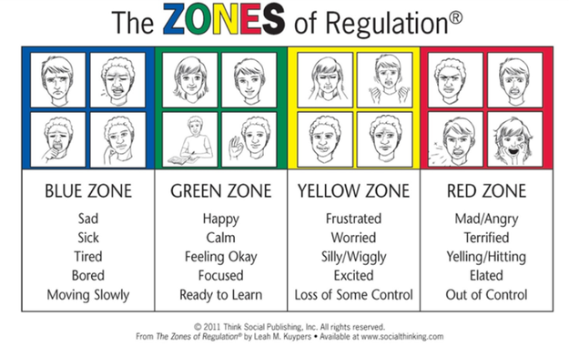

Rewards
As preparing for adulthood is such an important part of the ethos, we have adopted a reward system that replicates this. As such, we have developed a token economy called Barndale ‘Bling Bitz’. If our young people are in the green zone and making good choices, they receive gold tokens that go in their own blue token bags. On a Friday, the school shop is opened and our young people can spend their ‘Bling Bitz’ in the shop. We also celebrate achievements through certificates and stickers across the school. On a Friday Head teacher’s Awards are also given.

The THRIVE Approach
Barndale School has adopted the Thrive Approach and is currently establishing a whole school approach to allow all staff to implement key strategies regularly, repeatedly and consistently. Currently the Deputy Head-teacher and another Class-teacher are licensed Thrive Practitioners and as such are to assess pupils following set principles, devise individual action plans and suggest strategies to be used across the curriculum and throughout the school and residential facility.
Thrive is a systematic approach to the early identification of emotional developmental need in young people and young people so that differentiated provision can be put into place quickly by the adults working most closely with the child or young person. The Thrive Approach can make learning more accessible, more effective and more fun. It enhances emotional literacy and directly contributes to the development of learning across the social and academic curriculum. It is preventative, reparative, and pragmatic and assists young people and young people to develop resilience and resourcefulness.

Safeguarding
Keeping Young people Safe in Education
Under the 2016 policy (updated September 21) from the Dept. for Education, schools have a duty of care in ensuring the safety of all young people. Any concerns are discussed with parents/carers directly unless it was felt that the child was at risk of harm.
Our designated safeguarding leads are:
- Mark Phillips (Headteacher)
- Helen Hemsley (Deputy Headteacher),
- Katrina Green (Head of Care) &
- Sharon Thompson (Shift Coordinator)

Our Governor responsible for safeguarding is:
- Dr Christopher Benjamin

Safeguarding
Keeping all members of the Barndale community safe is an incredibly important part of our role. As such, we have an extensive safeguarding portfolio that covers: health & safety in the building, staff recruitment, site risk assessments, out of class visit protocol, child protection, e-safety, intimate care, PREVENT etc.

We are part of the North and South of Tyne Safeguarding Young people Partnership and as such follow procedures and policies as part of a larger collective.

The designated safeguarding lead is responsible for managing allegations and would liaise with the Local Authority LADO in the event of an allegation being made.

Digital Safety
Barndale House School works with a broad range of learners with complex needs. Many of our students have access to the digital world through a variety of devices both within school and at home. We recognise both the value and the vulnerabilities this brings and as such will capture these in this policy along with appropriate measures to safeguard our young people.

Our school aims to:
- Have robust processes in place to ensure the safety of pupils, staff, volunteers and governors when using digital devices
- Deliver an effective approach to online safety, which supports us in protecting and educating pupils, staff, volunteers and governors
- Establish clear mechanisms to monitor/identify, intervene and escalate an incident, where appropriate
- Develop confidence in becoming a positive digital citizen, including how to manage digital footprints and vulnerability online

Prevent
Barndale House School is fully committed to safeguarding and promoting the welfare of all its pupils. Every member of staff recognises that safeguarding against radicalisation and extremism is no different to safeguarding against any other vulnerability in today’s society. The Tackling Extremism and Radicalisation Policy sets out our beliefs, strategies and procedures to protect vulnerable individuals from being radicalised or exposed to extremist views, by identifying who they are and promptly providing them with support.

Criminal Exploitation
Criminal exploitation is child abuse where young people and young people are manipulated and coerced into committing crimes. This can be through gang activity and can involve county lines (moving drugs), financial abuse, carrying weapons, sexual exploitation and anti-social behaviour. Our staff are vigilant and aware of any signs of exploitation.

Operation Encompass/Endeavour
Operation Encompass and Endeavour is a police and education early information safeguarding partnership enabling schools to offer immediate support to young people who have experienced domestic abuse/going missing.

Working Together
Barndale House school actively works with CYPS, Young people’s Services, Early Help Team, School nursing team, police, community services and health to actively support all of our young people.

Security
Barndale House School has an electronic swipe card system, which prevents any young people or young people exiting the building without adult supervision.
This does impose a ‘restriction of liberty’, but any young person who wishes to exit can do so (due to their high level of vulnerability) with an adult present.

Representation and complaints

Consultation - Young People’s forum
Wherever possible, our young people are encouraged to make choices about the day-to-day running of the residential provision and their daily routines. We ensure that we provide appropriate communication resources to enable our young people to express their views and wishes. We also listen to parents, carers and other advocates on their behalf. We hold a residential forum every half term covering a range of items including activities, menus, redecoration and equipment.

Daley Barber-Allen is our allocated governor who conducts unannounced monitoring visits every half term. Part of his role is to ensure the views of our young people are expressed, heard and acted on.

How to make a complaint
The Resi provision has a complaints procedure that is readily available to all our young people residing and anyone who wants to make a complaint. The complaints procedure is displayed in a simplified pictorial format on the Resi notice board, on the school website and in the young person’s guide.
Our young people are encouraged to voice and share any concerns with whom they choose.

Additional contacts to make a complaint:
Mr Daley Barber-Allen  Residential Governor  C/O Barndale House School,  Howling Lane  Alnwick,  NE66 1DQ | Mrs Sue Wildsmith  Chair of Governors  C/O Barndale House School,  Howling Lane  Alnwick,  NE66 1DQ

Ofsted
Piccadilly Gate
Store Street
Manchester
M1 2WD

Telephone 0300 1231231
Young people’s Commissioner
The Young people's Commissioner for England is Dame Rachel de Souza.

Rachel has a legal duty to promote and protect the rights of all young people and young people in England. Focussing on young people and young people with difficulties or challenges in their lives. Those living away from home, in or leaving care, or receiving social care services.

Rachel's work focuses on making sure that the adults in charge who make decisions and listen to what young people and young people say about things that affect them. She encourages adults, including the people making decisions about young people's lives, always to take their rights, views and interests into account.

Rachel is the ‘eyes and ears’ of young people in the system and the country as a whole and is expected to carry out her duties ‘without fear or favour’ of Government, young people’s agencies, and the voluntary and private sectors.
Rachel also provides advice to young people who are in or leaving care, living away from home or working with social services through her advice line, Help at Hand.

If you feel that, the people responsible for your care are not valuing your rights. You may contact the Office of the Young people’s Commissioner. Using the contact details below and ask for some help in addressing any concerns you have.

Young people's Commissioner for England
Sanctuary Buildings
20 Great Smith Street
London
SW1P 3BT

Phone us free on: 0800 528 0731
Tel: 020 7783 8330

Email us at: help.team@young peoplescommissioner.gov.uk

You can contact us anonymously
Our service is free and confidential. We make sure we keep the information you share with us private, unless we think you or another child or young person is unsafe – we then may share the information with other organisations that can help protect you. If we need to share the information with other people who could help, we will tell you what we are doing and why we have decided to do it.

Inspection and Monitoring by Independent Visitors
Ofsted
Ofsted is the Office for Standards in Education, Young people’s Services and Skills. They inspect services providing education and skills for learners of all ages. They also inspect and regulate services that care for young people and young people.
Ofsted regularly inspects Barndale House Residential Provision, usually once a year. Ofsted produce a report of their findings, which is available on the schools website. http://www.barndalehouse.northumberland.sch.uk/

Independent & Governor Visits
Standard 20 of the National Minimum Standards for Residential Special Schools stipulates that Barndale House Residential Provision arrange for a representative who is independent of the management of the school to visit the Residential Provision six times, spread evenly over the course of the academic year and complete a written report on the conduct of the Residential Provision.
Written reports of all monitoring visits are provided to the head teacher and presented to the governing body.

Our governing body and Senior Leadership Team appointed, Daley Barber-Allen to visit and report on the education and care provided by the residential provision, Head of Care and the residential care staff team.

Our Head of Care will ensure that an independent person visits Resi each half term. When the independent person is carrying out a visit, the Head of Care and staff must support the independent person to: interview the young people, their parents, relatives and persons working within the provision. The independent person is required to inspect the premises of the provision and the Residential Provision’s records (except for a child’s care records, unless the child and the child is placing authority consent) as the independent person requires.

A visit by the independent person to Resi may be unannounced. The independent person must produce a report about a visit, which sets out, in particular, the independent person’s opinion as to whether the young people are effectively safeguarded; and the conduct of the Provision promoting young people’s well-being. The independent person’s report may recommend actions that the Head of Care is required to complete in relation to the provision and timescales within, which the registered person must consider whether or not to take those actions.

The Standards (1-22) Residential Special Schools - National minimum standards.
This report will provide an independent view measured against these.

Daley can be contacted by:
Telephone:
Email: Daley.BarberAllen@thomasbewick.newcastle.sch.uk

GDPR
We have an assigned and trained GDPR officer at the Local Authority to ensure all aspects of our school are compliant. Specific information can be found in the school GDPR policy.
In line with General Data Protection Regulations (GDPR), a registration and permissions booklet will be sent home asking for your personal details and to give permission for photographs, visits, internet use, etc.
Please complete and return these forms to the School Office as soon as possible.

