23 September 2020

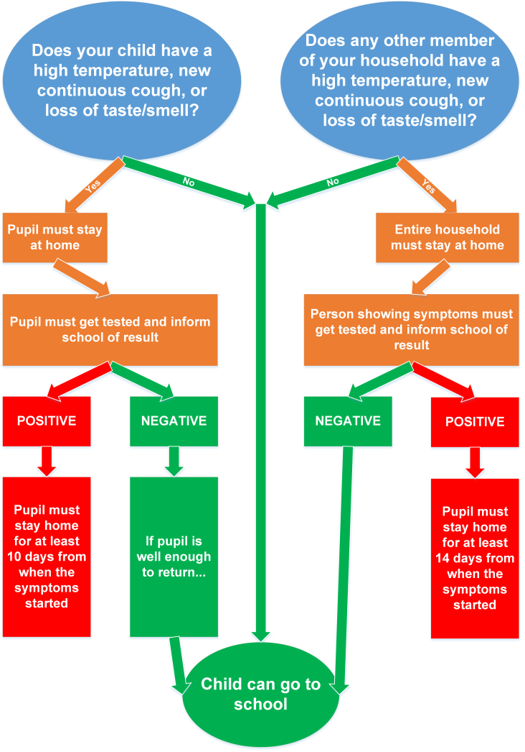
Dear Parents/Carers,

COVID-19

Can I firstly thank you for all your support in ensuring your young people get into school. I know while many of us still remain anxious we are all doing our very best to make sure we are following the guidance and keeping each other safe. At Barndale we are maintaining our school bubbles, continuing the regular cleaning and staying alert of any symptoms. This flowchart should help you identify if your child should be attending school:

Residential

We were hoping our residential provision would have been opening next week but we need to delay this for another week. This is to ensure that staff have had time to run through the new risk assessments for intimate care, cleaning and use of the residential provision, we will put these on the website for you to view as well.

We have also had some new staff joining the team and it has taken longer than expected to ensure their relevant paperwork has been completed by other agencies. If your child has previously accessed Residential, Tina Green, our Head of Care will be in touch to confirm nights and arrangements with you shortly. The residential staff have been great over the past few weeks in supporting the young people around school. Next week they will take the students up to show them their rooms, run through the routines and activities ready for week beginning 5th October 2020. We won't be admitting any new pupils to the residential provision just yet, but once we do we will let everyone know.

Multidisciplinary Working

I am really excited that this year we will have an intervention team based in school on a Thursday. We had our first meeting last week to look at key areas across the school and to look at our pupils to see which progammes would best suit them. The intervention team will be working with the classroom teams, small groups and individual pupils to enhance the offer we have at Barndale. Once this has been established I know they will work with you too in developing programmes and finding solutions to things at home that may be tricky. So far our intervention team includes staff from:
- Speech and Language Therapy (every week)
- Occupation Therapy (every week)
- Hearing Impairment Service
- Visual Impairment Service
- Multiple Sensory Impairment Service
- School Nursing (every week from October)
- Physiotherapy
- We are also hoping to include staff from CYPS
Although all the professionals have different caseloads we have chosen a Thursday to ensure they can work in collaboration with each other.

School Nursing & Medication

Historically, Barndale has always been fortunate to have a full time nurse within school - due to various reasons this offer has been reduced to 1 day a week starting October. As such medication and first aid will be managed by staff. If your child is required to have any medication within school, prescribed or over the counter, a form will need to be completed. This will be on the website or available from the school office. Any medication must be in the original packaging. Can we also ask that we get a copy of any clinical letters (NHS medication, treatment plans or diagnoses) to keep our records up to date.

Fundraising

Thank you to those parents who have come forward with ideas for fundraising. Barndale for many years has really struggled to fund exciting projects from the school budget and we rely heavily on donations and fundraising to give our students the very best. We currently have a few ideas in the pipeline for developing our outdoor areas, especially due to the further restrictions from COVID, to ensure we still have a quality PE offer. We do have a Go Fund Me live to try and acquire a new school vehicle. https://uk.gofundme.com/f/busforbarndale

We are continuing to update our school website with information, guidance and support- http://www.barndalehouse.northumberland.sch.uk/website/coronavirus/468398.

Finally, a massive thank you for your continued support of the school; it is such an unprecedented time in schools just now but I know that myself and all the Barndale team really appreciate your support and help along the way. If there is anything else we can do for you then please let us know.

Mark Phillips
Acting Headteacher

