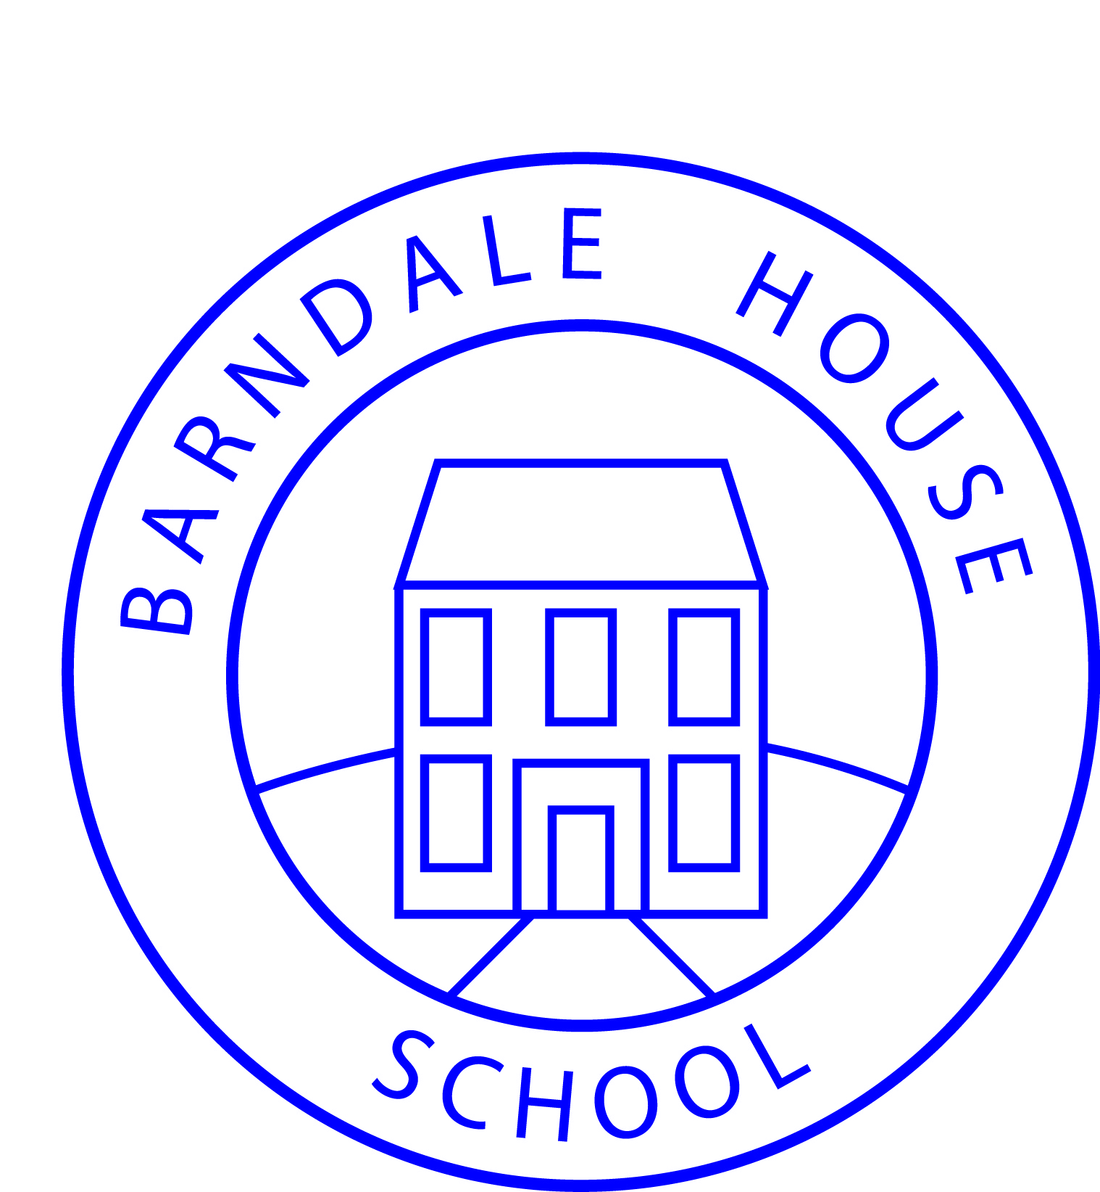

**Howling Lane, Alnwick, Northumberland, NE66 1DQ**

**Phone: 01665 602541**

**Fax: 01665 606370**

**E-mail: admin@barndalehouse.northumberland.sch.uk**

**Web: www.barndalehouse.com**

**Headteacher — Colin Bradshaw**

**RESPONSIBLE USE OF THE INTERNET**

As part of pupils’ curriculum enhancement and the development of ICT skills, Barndale House School provides supervised access to the Internet which may include email and video conferencing.

Our School Internet Provider operates a filtering system that restricts access to inappropriate materials and video conferencing. The School uses the educational broadband network to ensure quality of service and security.

The access that pupils have to the Internet will be highly planned for and appropriate to their educational needs. A copy of the Rules for Responsible Internet Use in operation at Barndale House School is overleaf.

C:\Users\Sally.Carrigan\AppData\Local\Microsoft\Windows\Temporary Internet Files\Content.IE5\01MO6WWY\MC900014896[1].wmf.....................................................................................................................................................

**PERMISSION FOR INTERNET ACCESS**

Pupil’s Name: .............................................................

|  |  |
| --- | --- |
| **Parent/Carer Permission**    I give Internet access permission on the terms set out in the Responsible Use of the Internet.  Signed: ...............................................................  Print Name: .......................................................  Date: .................................................................. | **Pupil’s Agreement**  I agree to follow the Rules for Responsible Use of the Internet.  Signed: ...............................................................  Print Name: .......................................................  Date: .................................................................. |

**RULES FOR RESPONSIBLE USE OF THE INTERNET**

The School uses computers and Internet access to help our learning. These rules will keep everyone safe and help us to be fair to others.

I will only access the system with my own login and password, which I will keep secret;

I will not access other people’s files;

I will only use the computers for school work and homework;

I will not bring any portable data storage into School;

I will ask permission from a member of staff before using the Internet;

I will not download program files from the Internet;

I will only email people I know, or my teacher has approved;

The messages I send will be polite and sensible;

I will not give my home address or telephone number, or arrange to meet someone;

To help protect other pupils and myself, I will tell a teacher if I see anything I am unhappy

with or I receive messages I do not like; and

I understand that the School may check my computer files and may monitor the Internet

sites I visit.